WEEK 7
TASK 1: STORAGE METHOD COMPARISON
- Shared Preferences
Advantages
- Easy to use and implement.
- Suitable for storing small amounts of data such as user settings, login status, and preferences.
- Data is stored locally on the device and can be accessed quickly.
- Requires very little storage space.
Disadvantages
- Can only store simple data types such as strings, integers, and booleans.
- Not suitable for large amounts of data.
- Does not support complex queries or relationships between data.
- Data is stored only on one device and is not automatically synchronized.

2. SQLite
Advantages
- Can store large amounts of structured data.
- Supports complex queries, sorting, filtering, and data relationships.
- Works offline since data is stored locally on the device.
- Provides better organization of data through tables.
Disadvantages
- More difficult to set up and manage compared to Shared Preferences.
- Requires knowledge of SQL commands.
- Managing databases can become complex as the application grows.
- Data is limited to the local device unless additional synchronization is implemented.

3. Firebase
Advantages
- Stores data in the cloud, allowing access from multiple devices.
- Provides real-time data synchronization.
- Includes built-in user authentication and security features.
- Reduces the need to manage your own server infrastructure.
- Easy integration with Android applications.
Disadvantages
- Requires an internet connection for most features.
- Free plans have usage limits.
- Costs can increase as the application grows.
- Dependence on a third-party service provider.

4. Internal Storage
Advantages
- Data is stored securely within the application.
- No internet connection is required.
- Other applications cannot easily access the stored files.
- Suitable for storing private files such as documents and images.
Disadvantages
- Storage space is limited by the device.
- Files are deleted when the application is uninstalled.
- Not suitable for sharing data between different applications.
- Managing large numbers of files can become difficult.
Field Name | Data Type | Description
StudentID | INT | Unique student identification number
Name | VARCHAR (100) | Student's full name
Course | VARCHAR (100) | Course enrolled by the student
Year | INT | Current year of study
PhoneNumber | VARCHAR (15) | Student's phone number
Primary Key: StudentID

CONTINUATION OF STUDENT MINI APPLICATION
Fig 1.0: Register Student
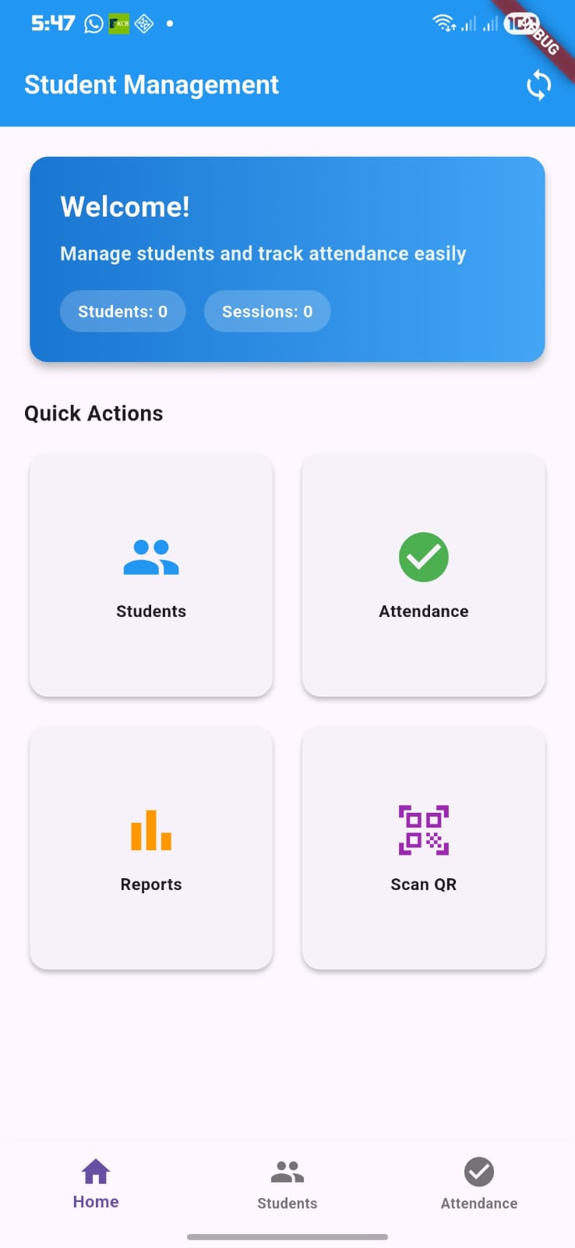


Fig1.1: Store Attendance Record
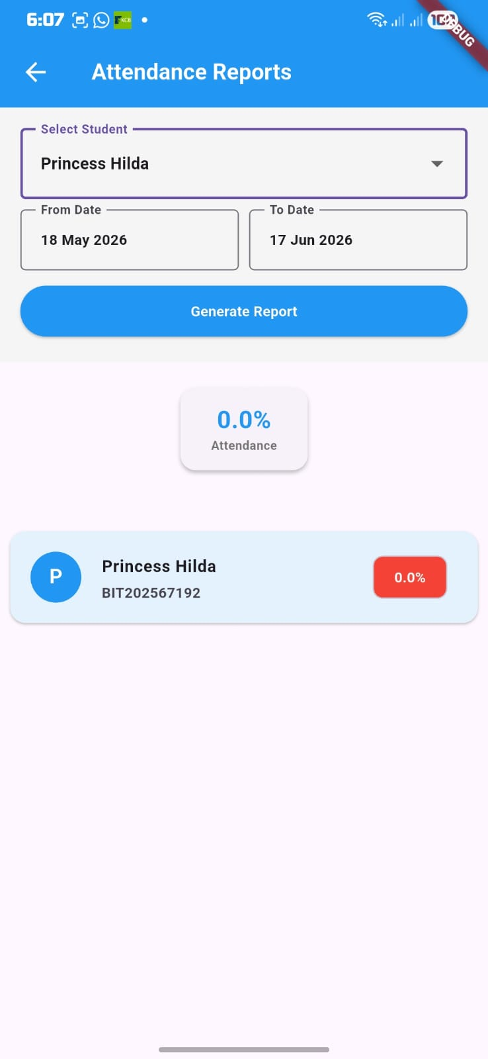 Figure1.2: Student Attendance Report

